Task 4 Report – AI-Based Image Upscaling

Objective:
Enhance a low-resolution image (task4_img.jpg) by 4x using AI-based super-resolution methods and compare with traditional interpolation methods (Nearest-neighbor and Bicubic).
1. Methods Used:
- Nearest-neighbor Interpolation:
  - A simple method that replicates pixels.
  - Fast but produces blocky and jagged images.
- Bicubic Interpolation:
  - Uses weighted average of 16 neighboring pixels.
  - Produces smoother results but can blur fine details.
- Real-ESRGAN (Enhanced Super-Resolution GAN):
  - Deep learning-based model trained on large datasets.
  - Adds realistic and high-frequency details.
  - Inference was done with --fp32 flag due to lack of GPU support for half precision.

2. Observations:
- Nearest upscaling created highly pixelated blocks with no new information.
- Bicubic was better, but still missed fine edges and produced slightly blurred textures.
- Real-ESRGAN clearly enhanced text clarity and preserved structural features with sharp boundaries.

4. Conclusion: AI-based upscaling using Real-ESRGAN significantly outperformed traditional methods in both quality and detail recovery. Despite longer processing time and setup complexity, it is the recommended approach for production-level enhancement.

Result:
Original Image: task4_img.jpg

Nearest Upscaled: nearest_x4.jpg


Bicubic Upscaled: bicubic_x4.jpg
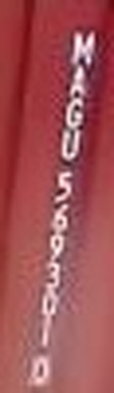

AI Upscaled: results/task4_img_out.png
